Experiment 18
Program:
import cv2
img = cv2.imread("image.jpg")
roi = img[100:300,100:300]
img[50:250,300:500] = roi
cv2.imshow("Result", img)
cv2.waitKey(0)
cv2.destroyAllWindows()
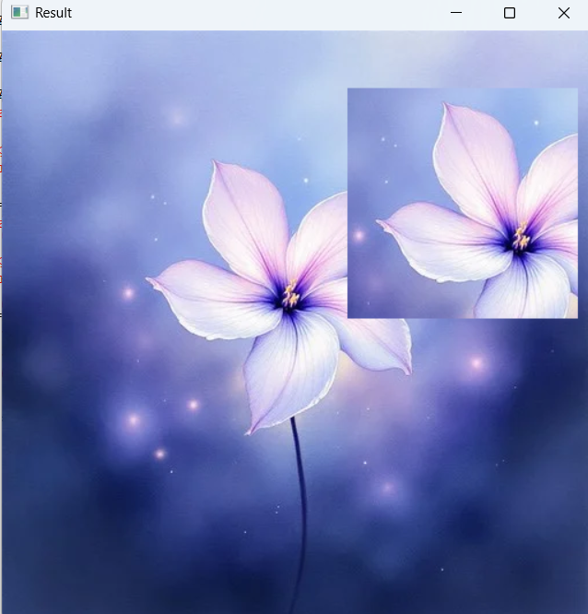
Output:

